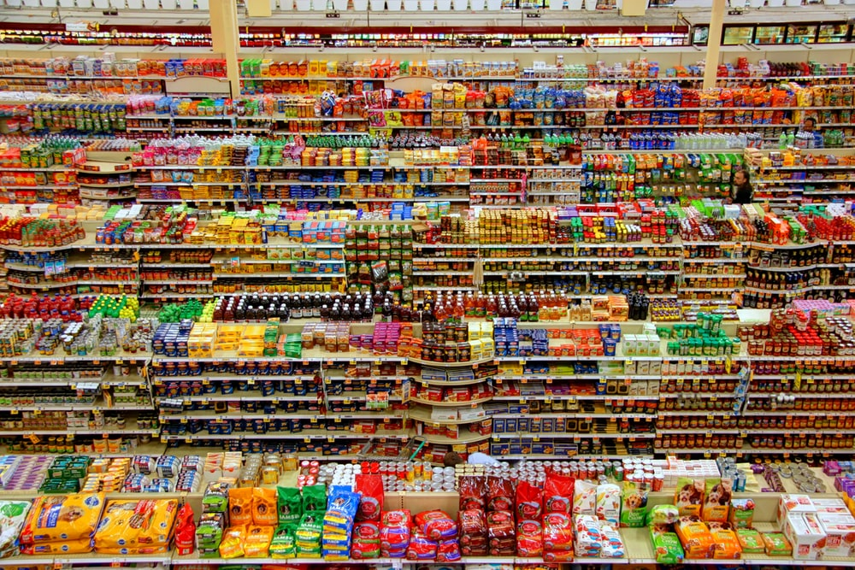

|  |
| --- |
| **SUPERMARKET PERFORMANCE REPORT** |

|  |  |  |
| --- | --- | --- |
|  |  |  |
|  |  |  |

TABLE OF CONTENTS

I. **Executive Summary** 3

II. **Analysis Plan** 4

Industry of Focus 4

Business Case 4

Business Questions 4

Key Stakeholders 4

Dataset 4

Key Performance Indicators 4

Metrics 4

III. **Analysis Process** 5

Dataset Used 5

Key Findings 6

City Sale Performance 6

Monthly Sale Activity 7

Member vs Normal 8

Sale Performance of Each Product 9

IV. **Conclusion** 10

V. **Recommendation** 11

# i.Executive summary

The Increasing of People shopping online due to world wild situation and the number of Store and Market rising up everyday ,make thing hard for Supermarket to keep their revenue stable.

According to the competitive market nowadays we really need the good strategies

in order to keep the business running ,we offer this analysis for give advantage to Supermarket make the good decision by some following below :

The customer type give the opportunity to increase Sale

The most vs the least sold product in any city

|  |
| --- |
| people at a table working |

# II.analysis plan

**Industry of Focus**

**(Retail)**

**Retail** is the sale of [goods](https://en.wikipedia.org/wiki/Goods) and [services](https://en.wikipedia.org/wiki/Service_(economics)) to [consumers](https://en.wikipedia.org/wiki/Consumer), in contrast to [wholesaling](https://en.wikipedia.org/wiki/Wholesaling), which is sale to business or institutional customers. A **retailer** purchases goods in large quantities from [manufacturers](https://en.wikipedia.org/wiki/Manufacturing), directly or through a wholesaler, and then sells in smaller quantities to consumers for a [profit](https://en.wikipedia.org/wiki/Profit_(accounting)). Retailers are the final link in the [supply chain](https://en.wikipedia.org/wiki/Supply_chain) from producers to consumers. [Shopping](https://en.wikipedia.org/wiki/Shopping) generally refers to the act of [buying](https://en.wikipedia.org/wiki/Trade) products. Sometimes this is done to obtain [final goods](https://en.wikipedia.org/wiki/Final_goods), including necessities such as food and clothing; sometimes it takes place as a [recreational](https://en.wikipedia.org/wiki/Recreation) activity.

**Business Case**

Improving Sales Performance Through Effective Marketing Strategy

**Business Questions**

Is the Customer Type really impacting the sale performance of the first 3 month?

What is the strategy to increase Membership Customer?

**Key Stakeholders**

Manager

Sale Team

Marketing Team

**Dataset :** Kaggle: Super Market Sale

**Link :** <https://www.kaggle.com/aungpyaeap/supermarket-sales>

**Key Performance Indicators**

-The main KPIs are Customer Type ,Total and Product Line

- The related KPIs are gender

**Metrics**

Microsoft Excel used for this finding

# III.Analysis process

Dataset Used

This dataset is one of the historical sales of supermarket company which has recorded in 3 different branches for 3 months data. Predictive data analytics methods are easy to apply with this dataset.

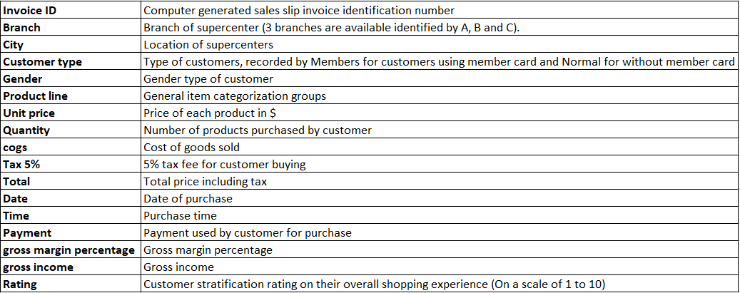

In order to use this data for analysis, we have to do some cleaning and manipulation processing as following below :

* Total ,unit price ,gross income, and cogs : need to change original format to $ format
* Date : Change format to Custom Date Format (DD/MM/YYYY) to easy to read
* Dataset : convert to Table for easy to insert Pivot table and do the dashboard

# III.Analysis process

## Key Finding

**1.CITY SALE PERFORMANCE**

Figure 1 : As you can you on the Bar Chart you can see there are 3 city ,The first city is Chicago, the most sold product in this city is Food and beverages and least sold product is home and lifestyle .In New York, Health and beauty can not perform well but Home and lifestyle is rising up for in the last 3 mouth. For San Francisco has Food and beverages that have low sale but has two product that sold the most Health and beauty and sport and travel.

# III.Analysis process

## Key Finding

**2.**M**onthly Sale Activity**

Figure 2 : In the Chart show us all product line that have been sold for the last 3 month , In January the line is high on Sport and travel .February has Food and beverages .Home and lifestyle perform well in March.

# III.Analysis process

## Key Finding

**3.** **Member vs Normal**

Figure 3 : we can see the different between the customer type . The total revenue from Member is 51% and only 49% from Normal .

# III.Analysis process

## Key Finding

**3.** **Sale Performance of Each Product**

Figure 4 : The most product have been sold of each month and City is Food and beverages and Health and beauty is the least sold product of the last 3 months.

# IV. Conclusion

This analysis has found a few factors that address the below problem : Improving Sale Performance Through Effective Marketing Strategy .

The problem above is come up with the answer based on the analysis below :

* Member Customer type buy more than Normal Customer type.
* The most product have been sold of each month and City is Food and beverages and Health and beauty is the least sold product of the last 3 months

# V. Recommendation

The Marketing team should focus on the problem that have been found through dataset:

* Member Customer type buy more than Normal Customer type that mean we need to focus on the strategy to make the normal customer subscription Supermarket offer for next month.
* As you can see in the chart Food and beverages perform well in the first 3 month, Increase Food and beverages for the next month.
* should have a strategy to promote Health and beauty to make more sale in the next month.
* The Product need Local Promotion for the next month base on **CITY SALE PERFORMANCE**:
  + Chicago: Should do promotion for Home and Lifestyle
  + New York: Should do promotion for Health and beauty
  + San Francisco: Should do promotion for Food and beverage